Guidebook for Pollinator and Rain Gardens

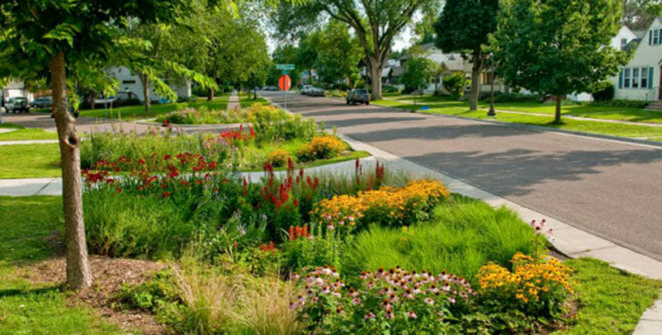

# Introduction

## Purpose

This document (prepared by the Eatontown Environmental Commission) is intended to provide an introduction and how-to guide for rain and pollinator gardens. The how-to guide relies heavily on referenced material.

## Audience

The primary audience includes those looking to create rain garden, pollinator garden or combination rain-pollinator garden.

## Document Location

An electron version of this document can be found at <https://github.com/sfratini33/eatontown-environmental-commission/blob/master/rain_pollinator-gardens/Pollinator%20-%20Rain%20Gardens.pdf>

# Definitions

## Pollinator Garden

From the Wikipedia article entitled “Pollinator garden”:

A pollinator garden is planted and designed, with specific nectar and pollen producing plants, in a way that attracts pollinating insects known as pollinators. In order for a garden to be considered a pollinator garden, it should provide (but not limited to) the following: various nectar producing flowers, shelter or shelter providing plants for pollinators, avoid the use of pesticides, and place similar flowers close to one another.

A series of free planning guides for pollinator gardens in various regions of the United States and Canada are available from the Pollinator Partnership. New Jersey is located in what is called the Eastern Broadleaf Forest: Oceanic Province (see the pollinator guide <https://www.pollinator.org/PDFs/EasternBroadleaf.Oceanic.rx18.pdf>).

Yet another free guidebook, entitled “Attracting Pollinators to Your Garden Using Native Plants,” can be found at <https://www.fs.fed.us/wildflowers/pollinators/documents/AttractingPollinatorsEasternUS_V1.pdf>.

## Rain Garden

From the Wikipedia article entitled “Rain garden” [2]:

Rain gardens, also called bioretention facilities, are one of a variety of practices designed to treat polluted stormwater runoff. Rain gardens are designed landscape sites that reduce the flow rate, total quantity, and pollutant load of runoff from impervious urban areas like roofs, driveways, walkways, and parking lots, and compacted lawn areas. Rain gardens rely on plants and natural or engineered soil medium to retain stormwater and increase the lag time of infiltration, while remediating and filtering pollutants carried by urban runoff. Rain gardens provide a method to reuse and optimize any rain that falls, reducing or avoiding the need for additional irrigation. A benefit of planting rain gardens is the consequential decrease in ambient air and water temperature, a mitigation that is especially effective in urban areas containing an abundance of impervious surfaces that absorb heat in a phenomenon known as the heat-island effect.

Rain garden plantings commonly include wetland edge vegetation, such as wildflowers, sedges, rushes, ferns, shrubs and small trees. These plants take up nutrients and water that flow into the rain garden, and they release water vapor back to the atmosphere through the process of transpiration. Deep plant roots also create additional channels for stormwater to filter into the ground. Root systems enhance infiltration, maintain or even augment soil permeability, provide moisture redistribution, and sustain diverse microbial populations involved in biofiltration. Microbes help to break down organic compounds (including some pollutants) and remove nitrogen.

Rain gardens can improve water quality in nearby bodies of water and recharge depleted groundwater supply. Rain gardens also reduce the amount of polluted runoff that enters the storm sewer system, which discharges directly to surface waters and causes erosion, water pollution and flooding. Rain gardens also reduce energy consumption by decreasing the load on conventional stormwater infrastructure.

Rain gardens are beneficial for many reasons; they improve water quality by filtering runoff, provide localized flood control, create aesthetic landscaping sites, and provide diverse planting opportunities. They also encourage wildlife and biodiversity, tie together buildings and their surrounding environments in integrated and environmentally advantageous ways, and provide significant solutions to important environmental problems that affect many aspects of life.

# Motivation

Pollinator gardens are intended to provide a safe habitat that is free from chemicals in help support the pollinator population. While pollinators include many types of creatures (e.g., bats, hummingbirds, various insects), the bee population is most under siege and in most need of safe habitats (see the articles on bee colony collapse [3] and bee colony decline [4]).

On the other hand, the main motivation for rain gardens is to control stormwater run-off by directing a portion of the run-off to the underlying substrate rather than the stormwater system. Rain gardens make use of vegetation and soil medium to retain stormwater and increase the lag time of infiltration, while remediating and filtering pollutants carried by urban runoff.

No pesticides, herbicides or toxic chemicals should be used in (or afforded access to) either type of garden. However, rain gardens can be used to collect run-off from parking lots (which could have various oils and chemicals from cars) and from house or business roofs (again, there could be chemicals from the roof material). It is advised not to place pollinator gardens in such scenarios.

# How-to

## Pollinator Gardens

The document “Project Pollinator – Building Gardens for Pollinators – A Comprehensive “How-to” Guide” is recommended as primary reading (see <https://www.fws.gov/uploadedFiles/ProjectPollinator_Guide%20(1).pdf>).

Some additional resources:

* “Create a Pollinator Garden: Everyone Can Grow a Garden”, see the video at <https://youtu.be/k6NXOz2ExZo>. This is an example of a rather large pollinator garden.
* “How to build a pollinator garden” from the U.S. Fish and Wildlife Service: <https://www.fws.gov/midwest/news/PollinatorGarden.html>
* “Gardening for Pollinators” from the U.S. Forest Service: <https://www.fs.fed.us/wildflowers/pollinators/gardening.shtml>
* “How to Make a Pollinator Garden” from See What Grows: <https://www.seewhatgrows.org/make-pollinator-garden/>
* “How to Make a Pocket Pollinator Garden” from Get Green Be Well: <https://www.getgreenbewell.com/how-to-make-a-pocket-pollinator-garden/>
* “How to create a pollinator-friendly garden” from the David Suzuki Foundation: <https://davidsuzuki.org/queen-of-green/create-pollinator-friendly-garden-birds-bees-butterflies/>
* Jersey Friendly Yards ([https://www.jerseyyards.org](https://www.jerseyyards.org/)) has a database of plants native to New Jersey, an online garden planning application and an “Ask an Expert” feature.
* The Native Plant Society of New Jersey ([http://www.npsnj.org](http://www.npsnj.org/)) has a wealth of information concerning plants and trees that are native to New Jersey.

## Rain Gardens

The article “How to Create an Effective Rain Garden” is recommended as primary reading (see <https://content.yardmap.org/learn/how-to-create-effective-rain-garden/>). This article provides detailed steps for creating a rain garden.

Also, the Rain Garden Design document from Rutgers University has a helpful checklist and detailed design recommendations for rain gardens. The document is freely available at <https://tinyurl.com/y5f8s7kl>.

Some additional resources:

* Rain Gardens from the University of Maryland Extension: <https://extension.umd.edu/watershed/rain-gardens>
* App that helps with the design of a rain garden: <https://nemo.uconn.edu/tools/app/raingarden.htm>
* “5 Steps to Make a Rain Garden” from Better Homes and Gardens: <https://www.bhg.com/gardening/landscaping-projects/landscape-basics/make-a-rain-garden/>
* “Bioretention Illustrated: A Visual Guide for Constructing, Inspecting, Maintaining and Verifying the Bioretention Practice”: <http://chesapeakestormwater.net/wp-content/uploads/downloads/2013/10/FINAL-VERSION-BIORETENTION-ILLUSTRATED-102113.pdf>
* “Woody Shrubs for Stormwater Retention Practices” from Cornell University Department of Horticulture: <http://www.hort.cornell.edu/uhi/outreach/pdfs/woody_shrubs_stormwater_low_res.pdf>
* Rain Garden Fact Sheet from Rutgers: <http://water.rutgers.edu/Stormwater_Management/fs513.pdf>.

## Combined Rain / Pollinator Gardens

While in principle it is possible to create a combined rain / pollinator garden, there is virtually nothing on the web that directly addresses this issue. The requirements are not the same, e.g.,

* it is acceptable to have a rain garden to collect run-off from a parking lot but not a good idea for a pollinator garden given the oil and other stuff than can leak from cars onto the parking lot surface and then into the rain garden
* a rain garden needs good drainage to the ground below but this is not as important for a pollinator garden (could even do this with a collection of potted plants on a concrete patio).

If a combination rain / pollinator garden is to be constructed, plants that can handle a lot of water should be used (this will exclude some pollinator friendly plants).

# Eatontown’s Pollinator Garden

Within the Eatontown Community Garden (located just East of Husky Brook Park), the Eatontown Environment Commission has prepared a pollinator garden. This garden is described further in the associated brochure entitled “TBD.”

# References

1. Pollinator garden, Wikipedia, <https://en.wikipedia.org/wiki/Pollinator_garden>, accessed 11 October 2020.
2. Rain garden, Wikipedia, <https://en.wikipedia.org/wiki/Rain_garden>, accessed 11 October 2020.
3. Colony collapse disorder, Wikipedia, <https://en.wikipedia.org/wiki/Colony_collapse_disorder>, accessed 12 October 2020.
4. Neilson, S., “More Bad Buzz For Bees: Record Number Of Honeybee Colonies Died Last Winter”, NPR, <https://www.npr.org/sections/thesalt/2019/06/19/733761393/more-bad-buzz-for-bees-record-numbers-of-honey-bee-colonies-died-last-winter>, accessed 12 October.